


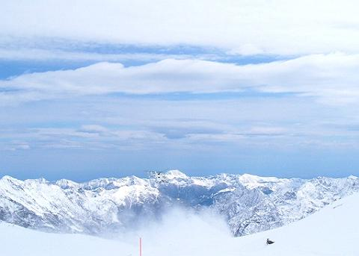


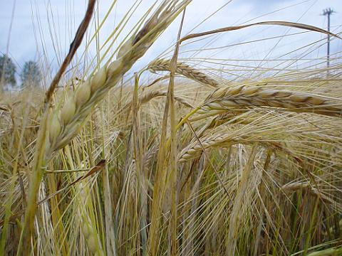
Creating innovative solutions for your unique needs




InvertedLogic
One Stop Linux Shop

http://www.invertedlogic.com

3-1309 Yang Guang Du Shi
18 Xin Zhong Jie
Dong Cheng Qu
Beijing, P.R. China

+86 139 10027352

info@invertedlogic.com

Stock photos from: http://www.freephotos.se/
InvertedLogic and certain other trade names, trademarks and logos are trademarks or registered trademarks of InvertedLogic.All other trademarks, logos or source marks are the property of their respective owners. Specifications are subject to change without prior notice.

All rights reserved.
Copyright © InvertedLogic 2008

